

A PROJECT REPORT ON

EFFECTIVE PRESENTATION STRATEGIES

Submitted To: Submitted By:

Prof. Dr. Neha Sharma 1. Rhishikesh Chaughule (14)

2. Vinayak Kapale (32)

3. Nitish Betkekar (47)

4. Aditi Patil (49)

5. Sakshi Rasal (61)

6. Adnan Shaikh (68)

7. Juveriya Tamboli (72)

Department of Computer Engineering Academic Year

(2021-2022)



**CERTIFICATE**

This is to certify that the project report entitled ‘Effective Presentation Strategies’ has been successfully carried out by Rhishikesh Chaughule, Vinayak Kapale, Nitish Betkekar, Aditi Patil, Sakshi Rasal, Adnan Shaikh and Juveriya Tamboli in the subject ‘Professional Communication And Ethics II’ in the partial fulfilment of Third Year Computer Engineering for the academic year 2021-2022 as prescribed in the curriculum under the guidance of Dr. Neha Sharma.

Principal HOD Project Guide

**PREFACE**

Everyone has probably attended a presentation at one time or another led by a charismatic presenter who leveraged effective facilitation techniques to draw audience participation and whose enthusiasm about the topic was contagious. Whether the presentation was to provide information or to illicit a call to action, the presenter’s skills and structure of the content probably had a great deal of impact on what we remembered and acted on after the presentation.

The thought of giving a presentation often ranks at the top of the list of what people fear the most. So how do we go about developing and delivering an effective, memorable presentation? This project report provide key information we need to accomplish successful presentation and encompasses 6 chapters. Chapter 1, Introduction, presents overview of important topics for Effective Presentation. Chapter 2, Types, include points that makes presentation successful. Chapter 3, Audience Analysis, deals with importance of audience. Chapter 4, Standard Presentation Structure, discuss about flow of presentation. Chapter 5, Characteristics, presents the characteristics of effective presentation. Chapter 6, Conclusion, Conclude the project report by summarizing all the key points.

**ACKNOWLEDGEMENT**

It has been a great experience to work on the project ‘Effective Presentation Strategies’ and we learned various things from this topic like planning, analysing audience, presentation quality, managing time, body language and reducing anxiety.

We would like to express our thanks to Dr. Neha Sharma for guiding us throughout this project work. And we also would like to thank her for motivating us in different ways. She has been a great helping hand in the completion of this project.

We feel there is ample scope of improvement in the work of this nature and shall be thankful if any suggestion is offered in its improvement. We are also thankful to all the people who have directly or indirectly contributed in the completion of this project.

# TABLE OF CONTENTS

|  |  |  |
| --- | --- | --- |
| **SR NO.** | **CHAPTER NAME** | **PAGE NO.** |
| 1. | Introduction | 1-5 |
| 2. | Types of Effective Presentation Strategies | 6-13 |
| 3. | Audience Analysis | 14-20 |
| 4. | Standard Presentation Structure | 21-22 |
| 5. | Characteristics of Effective Presentations | 23-31 |
| 6. | Conclusion | 32 |
|  | Bibliography |  |

**CHAPTER 1**

**INTRODUCTION**

**CHAPTER 1**

**INTRODUCTION**

A Presentation is a fast and potentially effective method of getting things done through other people. In managing any project, presentations are used as a formal method for bringing people together to plan, monitor and review its progress. Whether you are a student or an employee of a business organization, it is essential to possess good public speaking skills. Employers are demanding people with excellent communication (written, oral, and listening) skills. Presentation skills are important for every individual. To mention a few, as a team leader you may have to present before the corporate body about the product your team brought out; as top administrator of an organization you may have to present your goals, activities and achievements to an important visitor; as project manager you may have to present before a committee the results of a project and so on. In addition, if you are a student you may have to attend seminars, present papers. These situations call for effective memorable presentations. Thus, a presentation becomes an important element in delivering positive learning experiences. "Well-organized presentation" and "enjoyable content" were the two most important measures of presentation effectiveness. The ability to make effective and memorable oral presentation is the important qualities in the successful career of an individual. Constant practice is the key to acquiring these skills.

**Overview of important topics for Effective Presentation:**

1. **To make a good presentation, you need to consider the 4Ps:**

* A well-defined purpose
* Thorough preparation
* A well-structured presentation, with clear delivery
* Careful post-evaluation of how well it was understood.

1. **Design:** There is no question that a well-designed presentation will contain effective visuals, most often in the form of PowerPoint slides. Thus, the design of visuals matters. Standard design principles:

* Keep it simple
* Understand the cognitive load theory
* Choose Fonts Wisely
* Effective Imagery

1. **Delivery:** 'Delivery' refers to the way in which you actually deliver or perform or give your presentation. Delivery is a vital aspect of all presentations. Delivery is at least as important as content, especially in a multi-cultural context.
2. **Nerves:** Most speakers are a little nervous at the beginning of a presentation. So it is normal if you are nervous. The answer is to pay special attention to the beginning of your presentation. First impressions count. This is the time when you establish a rapport with your audience. During this time, try to speak slowly and calmly. You should perhaps learn your introduction by heart. After a few moments, you will relax and gain confidence.
3. **Audience Rapport:** You need to build a warm and friendly relationship with your audience. Enthusiasm is contagious. If you are enthusiastic your audience will be enthusiastic too. And be careful to establish eye contact with each member of your audience. Each person should feel that you are speaking directly to him or her. This means that you must look at each person in turn - in as natural a way as possible. This will also give you the opportunity to detect signs of boredom, disinterest or even disagreement, allowing you to modify your presentation as appropriate.
4. **Body Language:** What you do not say is at least as important as what you do say. Your body is speaking to your audience even before you open your mouth. Your clothes, your walk, your glasses, your haircut, and your expression - it is from these that your audience forms its first impression as you enter the room. Generally speaking, it is better to stand rather than sit when making a presentation. Be aware of and avoid any repetitive and irritating gestures. Be aware, too, that the movement of your body is one of your methods of control. When you move to or from the whiteboard, for example, you can move fast or slowly, raising or reducing the dynamism within the audience. You can stand very still while talking or you can stroll from side to side. What effect do you think these two different approaches would have on an audience?
5. **Cultural Considerations:** Because English is so widely used around the world, it is quite possible that many members of your audience will not be native English-speakers. In other words, they will not have an Anglo-Saxon culture. Even within the Anglo-Saxon world, there are many differences in culture. If we hypothetically imagine a German working for an Israeli company making a presentation in English to a Japanese audience in Korea, we can see that there are even more possibilities for cultural misunderstanding. You should try to learn about any particular cultural matters that may affect your audience. This is one reason why preparation for your presentation is so important. Cultural differences can also be seen in body language, which we have just discussed. To a Latin from Southern France or Italy, a presenter who uses his hands and arms when speaking may seem dynamic and friendly. To an Englishman, the same presenter may seem unsure of his words and lacking in self-confidence.
6. **Audience Reaction:** Remain calm and polite if you receive difficult or even hostile questions during your presentation. If you receive particularly awkward questions, you might suggest that the questioners ask their questions after your presentation.

**CHAPTER 2**

**TYPES OF EFFECTIVE PRESENTATION STRATEGIES**

**CHAPTER 2**

**TYPES OF EFFECTIVE PRESENTATION STRATEGIES**

Being a skilled presenter requires a constellation of hard and soft skills.

1. **Research:** The first step of any successful presentation is the research and preparation phase. First and foremost, you have to become an expert on the content you hope to deliver. It’s also essential to research your audience to know which information is most pertinent for them.
2. **Planning:** Once you’ve completed your research, it’s time to develop a plan. During this phase, you’ll prioritize which information gets put front-and-centre, and which is less vital for your ultimate goal.

Before you start drafting your presentation, it’s crucial to keep your goal at the forefront:

What do you want the audience to do after listening to your presentation?

Whether it’s convincing a client to purchase a service, landing for your dream job, or getting a few laughs at a wedding, your presentation’s goal should always be central in your plan.

1. **Organization:** Audiences prefer presentations that are well-thought-out and delivered in a logical order. Before you even step foot in the room, you should know what you need to do to set up, have all your notes in order, and be aware of your allotted time.

You should also always arrive early for a presentation, so you can organize anything that needs organizing before you start. That way, you won’t kick off your presentation futzing with wires while your audience starts drifting to their phones.

1. **Verbal Communication:** No surprises here, verbal communication skills are downright essential for an effective presentation. Even if you have very rigid notes to follow, being quick on your feet to answer questions or alter your content for the audience’s benefit will serve you well during presentations.
2. **Nonverbal Communication:** Good body language means standing up straight, not fidgeting too much, and maintaining eye contact with your audience members.

Additionally, your inflection, pace, and energy are all elements of nonverbal communication. Adjust these according to your audience (through research or in real-time), and you’ll be a more effective presenter.

Kinesics is the name given to the study of the body's physical movements. In other words, it is the way the body communicates without words. i.e., through various movements of its parts. E.g. nodding your head, blinking

**Kinesics include:**

1. **Personal Appearance:** Personal appearance plays an important role; people see you before they hear you. As you adapt your language to an audience, you should also dress appositely. Appearance includes clothes, hair, jewellery, cosmetics, and so on.
2. **Gesture:** Gesture is the movement made by hands, arms, shoulders, head and torso. Adroit gestures can add to the impact of speech. Gestures clarify your ideas or reinforce them and should be well suited to the audience and occasion.
3. **Posture:** The way that the body is held can communicate many different messages. An open body that takes up a lot of space can indicate comfort and domination, whilst a closed in body that make itself small can signal inferiority. Copying of the other person’s body shows agreement, trust and liking.
4. **Facial Expression:** Facial expressions also play an important role in presentation. The face is the most expressive part of our body. A smile stands for friendliness, a frown for discontent, raised eyebrows for disbelief, tightened jaw muscles for antagonism, etc.
5. **Eye Contact:** The eyes are considered to be the windows of the soul. You look to the eyes of a speaker to help find out the truthfulness of his speech, his intelligence, attitudes, and feelings. Eye contact is a direct and powerful form of nun-verbal communication.
6. **Public speaking:** Some people get nervous just thinking about speaking publicly. There’s nothing wrong with that, but it is crucial to keep your nerves under wraps for delivering the most effective presentation possible. Audiences are less likely to trust presenters who don’t appear confident.
7. **Memorization:** We’ve all seen presentations where the presenter is just reading directly off his PowerPoint slides – we don’t need to tell you that those presentations are unequivocally bad. It’s fine to have notes as a reference, but the more time you can spend looking at your audience rather than the sheet in front of you, the better.
8. **Writing:** Being a good writer will help keep your presentation organized and give a boost to your credibility. Before you can commit your content to memory, you need to develop that content.
9. **Story-telling:** Not all presentations require story-telling, but it can be a very effective method of grabbing your listeners’ attention. It can be a hypothetical story that presents a question or problem, a real story that leads into your main argument, or a story that continues throughout to illustrate the duller facts your presentation covers.

While we tend to associate story-telling with more informal presentations, it can be equally effective in a professional setting.

1. **Rhetorical Skills:** Rhetoric is all about persuasion:

How are your words going to induce action from the listener(s)? Rhetorical appeals are classified under three headings: ethos, logos, and pathos.

* **Ethos** establishes credibility in the speaker and trust in the listeners through confident delivery and expert testimony.
* **Logos** covers your presentation’s logical thrust through statistics, models, comparisons, analogies, etc.
* **Pathos** is your presentation’s emotional appeal, supported by vivid language and stories that promote certain values.

Every presentation will contain some element(s) of these rhetorical appeals, but the weight each gets depends on the situation.

1. **Active Listening:** Pay attention to which parts of your presentation are grabbing listeners and which are falling flat. If your audience’s eyes start glazing over or phones start coming out, you know you’re losing them.

Additionally, some presentations have a Q+A segment, so be ready to shut up for a second and give your full attention to each question.

1. **Adaptability:** Like the above point, being able to adapt on the fly sets top-tier presenters apart from merely good ones. For instance, if you can tell your presentation isn’t working, you can open up the floor and ask for questions as a way of determining your audience’s priorities.

Using the ample research you conducted, you can start steering the presentation towards areas of genuine interest.

1. **Delivery:** We bet you’ve heard some of the same Dad jokes multiple times in your life. Sometimes they’re hilarious, and sometimes they induce an eye-roll. The difference? Delivery. Pace, timing, tone, and enunciation/inflection are all important elements of good delivery.

It’s a tough thing to practice, but if you’ve got an anecdote to share in your presentation, maybe try it out on a few people beforehand using different delivery methods and see which works best.

1. **Technical Skills:** All right, you’re all set with the perfect presentation, you walk into the room, and the A/V set up isn’t what you were expecting. Well, if you followed our advice above, you showed up a bit early and had time to fix it.

Either way, being handy with different presentation software and just generally technologically-literate will lessen the stress associated with technical difficulties.

1. **Analysis:** Time to forget about presenting until the next one comes up, right? No – now is the time for you to take a step back and evaluate your performance.

What went well, where could you improve, and how did the audience respond? If you want to improve as a presenter, you must be continually tracking your strengths and weakness.

**CHAPTER 3**

**AUDIENCE ANALYSIS**

**CHAPTER 3**

**AUDIENCE ANALYSIS**

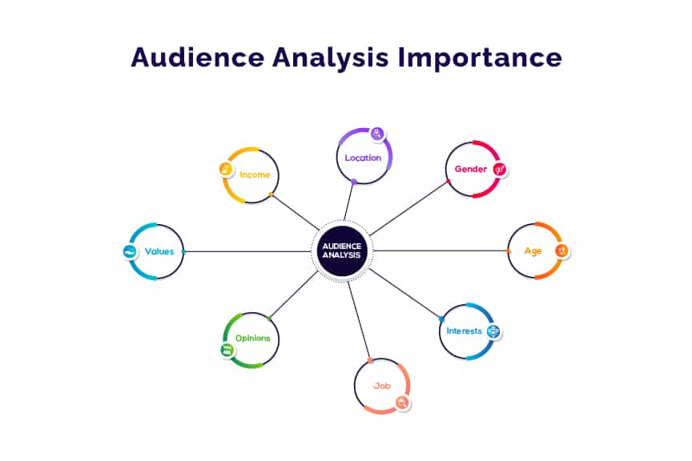

[Source](https://slidebazaar.com/blog/wp-content/uploads/2018/12/Audience-Analysis-Feature-Image.jpg.webp)

In the field of public speaking, audience analysis is a common term. If we have not analyzed our audience yet, we will be doomed on stage. Just like any other field, audience analysis is equally important in the case of any presentation too. If we don’t pose enough knowledge about our audience, then we can never have a successful presentation. The audience is the base of every presentation. Thus, it is really important to know and study our audience before we stand on the podium of our presentation. We cannot impress the people of our presentation if we do not study them well, right?

Connecting with our audience is a key part of persuading our audience. Even if one person is standing up front and speaking for 20 minutes straight, there are ways to make this type of communication feel like a conversation, not a lecture. To do so, we need to show our audience that we respect them, their time, their needs and their challenges. We need to demonstrate that we know our audience.

1. **What is Audience Analysis?**

Audience analysis entails identifying and understand the audience and adapting our speech to their interests, level of understanding, beliefs, and attitudes. Taking an audience-centered approach is important because if the presentation is created and delivered properly, it will improve the speaker’s effectiveness. Since identifying the audience through extensive research is challenging, audience adaptation often relies on assumptions and imagination. It’s not about telling an audience what they want to hear. Rather, it’s about the style, approach, and choice of words a speaker uses for maximum impact.

1. **Importance of Audience Analysis**

The preparation of a presentation is a hectic process in itself, let alone the process of audience analysis. And often people left the analysis thinking that it would be managed on stage. But in most cases, it cannot be managed because the audience is the one dynamic quotient of a presentation we often ignore. So, here are some of the importance of proper audience analysis. Let’s have a look.

* + **Better Communication** – Once we know our audience properly, we will be able to communicate in a better way. If we have a teenage audience forum, we have to relate to them to make our presentation more attractive. The same aspect applies in the case of other age groups as well.
  + **Better Presentation** – We cannot arbitrarily prepare our presentation. We must have a little knowledge about the nature of our audience, if not an audience analysis. And if we have a proper audience analysis, it would be more helpful while preparing our presentation for the little flaws, and the pros of preparing a presentation would be more prominent.
  + **The Audience Will Understand We Better** – In a session of presentation, it is not enough that we understand our audience, but it is important for our audience to understand simultaneously. This is called the ‘Audience Expectation.’ If we cannot meet the audience’s expectations, our whole presentation session will be a flop one anyway. We can make the presentation information more convincing and understandable using PowerPoint diagrams.

These three points are the three-layered importance of audience analysis. Audience analysis can be gained by simple interaction at the session or through advanced research. Depending on the method, audience analysis can be of three types as well.

1. **Types of Audience Analysis**

If we look deeper into this subject matter, it can be found that audience analysis is not just a simple process. Rather it has different layers, methods, and even types. Audience analysis can be categorized into three classes, and here, we are going to discuss this analysis in detail.

* **Demographic Audience Analysis** –

Demographic analysis can also be termed as an earlier advanced stage of audience analysis as well. Demographic analysis is done on the basis of several factors such as age, gender, culture, religion, education, occupation, etc. These factor analyses can only be done by research.

1. **Age** – Age is a very common factor in the case of demographic analysis. By categorizing an age group, a presenter can easily define them. Such as if the audience’s age is between 10 to 15 years, they have very specific experience in life, and they do not have any firsthand experience in life before a certain period. However, the same is not with people who come from an age group of forty or sixty years. These analyses can help a great deal while providing references.
2. **Gender** – Gender provides human experience. Woman and man both have their very different experiences in their life, and that helps we to cover how we are going to decorate our presentation.
3. **Culture** – Cultures are important while we are using a certain metaphor or certain factual terms. Not every people from every culture know of every other term. If our majority audience belongs from a particular culture, say European Culture, we ought to stick to strictly European references.
4. **Religion** – Religion is a wide variation while we are studying audience analysis. It plays a major role while we are shaping out our presentation slides.
5. **Education and Occupation** – Education and occupation provide great knowledge while we are shaping out our slides. If our audience crowd is from the labor class and have a limited education facility, it is better to stick to less fancy words and fact and vice versa.

* **Psychographic Audience Analysis** – Psychographic analysis mostly includes the attitude of the audience, values, opinions, and beliefs. Anything that is related to psychology falls into this category of analysis. In this type of analysis, we need to know whether people know about us from some earlier references or not such as any media stereotype, any newspaper headlines, etc. The psychographic analysis is not that very important for the newcomers, but people tend to undermine a first-timer. So, we have to analyze according to our position.
* **Situational Audience Analysis** – Situational analysis is something done at the moment of presenting a presentation. Situational analysis is mostly dependent on outside factors such as the size of the audience crowd, the occasion of the presentation, how voluntary the audience is, physical setting, etc. these four factors are really important as they set up the whole process of audience analysis. The size of the audience and physical setting decide whether we can freely communicate with the people or not. The voluntariness of the audience decides how free the people are and whether we can know them better through little conversations. Also, the occasion matters.
* **Pre-Presentation Analysis** – Analyzing the audience type can elevate the outcome of the presentation. For example, we have an upcoming corporate meeting, using a decorative presentation slide will distract our audience from the prime topic. Instead of fancy presentation slides, the presenter can opt for a simple and minimalist PowerPoint diagram.

So from the above types of audience analysis, we can prepare a set of questions that need to be answered before we can present a presentation. What are those?

1. **What We Need to Know From Audience?**

Before we can classify which type of audience analysis we will be doing, we need to answer a few questions first.

* + What their job or educational background is.
  + Their depth of knowledge on the topic we are presenting.
  + Their probable learning style.
  + How they like to be treated or how much they love to listen.
  + Their purpose of paying attention to our presentation.

This set of questionnaires will be helpful in case we are struggling with the process of audience analysis.

**CHAPTER 4**

**STANDARD PRESENTATION STRUCTURE**

**CHAPTER 4**

**STANDARD PRESENTATION STRUCTURE**

The structure of a research presentation is not absolutely fixed. It depends mostly upon the conventions of your research field and perhaps of the conference you are attending. But even then, there may be room to change if you like. It may surprise you, but the basic structure of typical presentations in the natural sciences, physical sciences and humanities are not radically different. In the sciences most researchers are familiar with what is called the IMRaD structure, meaning “Introduction, Method, Results and Discussion” for both articles and presentations. Certain areas of the humanities use that same structure. If you are working in a field such as philosophy or literary studies you may write and present in what is sometimes referred to as a “discursive” mode: you write or speak a long argument using almost entirely words, no numerical data. In that case, you may still describe your method because you might be using a particular theoretical approach, or maybe you don’t need that. As for the results and discussion parts, they may be together… it’s all discussion. But apart from that, much of the structure could be quite similar to a presentation in the sciences. In any case, you are trying to support an idea through a logical organization of evidence.

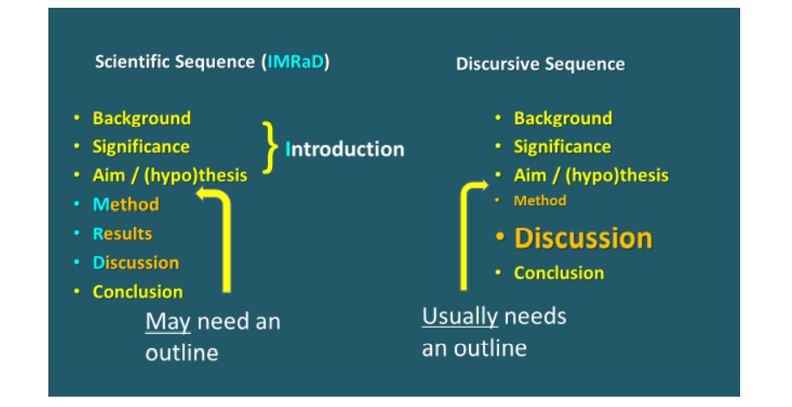

[Source](http://meiwriting.ilas.nagoya-u.ac.jp/pdf/Presentations%20book%202019-3.pdf)

Look at the diagram below, which could be used as a general presentation structure across various fields. In a scientific presentation, supporting parts A, B and C would probably be Method, Results and Discussion. In the humanities you might have any number of sections and any way of organizing them, so long as it has logical flow, coherence.

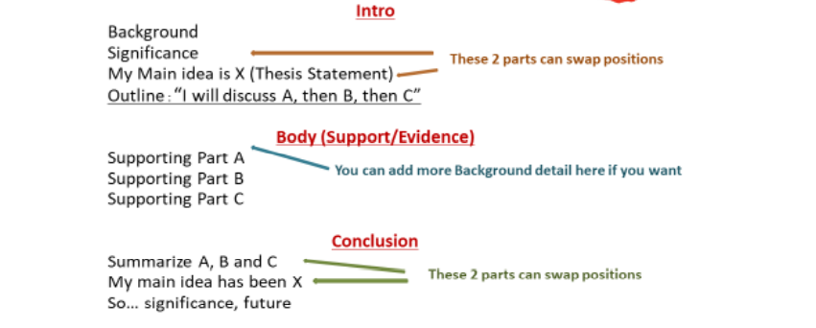

[Source](http://meiwriting.ilas.nagoya-u.ac.jp/pdf/Presentations%20book%202019-3.pdf)

**CHAPTER 5**

**CHARACTERISTICS OF EFFECTIVE**

**PRESENTATIONS**

**CHAPTER 5**

**CHARACTERISTICS OF EFFECTIVE PRESENTATIONS**

Communication is one of the most important skills of a leader. Public speaking can be terrifying, but when you care about your career progression you need to find a way to get your voice out.

Public speaking is how you can share your ideas with a large number of people, stand out from the corporate crowd, and get visibility in your field.

Unfortunately, if you’re public speaking skills are not up to par, it’s likely that no one will be focused enough on your presentation to really receive your message. Here are some characteristics of effective presentation strategies that you should emulate to become an influential and inspiring leader.

1. **Confidence:** According to a study published by the University of Wolver Hampton “A highly confident speaker is viewed as being more accurate, competent, credible, intelligent, knowledgeable, likable, and believable than the less confident uncertain speaker.”

When it comes to public speaking, confidence is key (not the only key mind you). When speaking in public, it’s only natural to be nervous. In fact, Mark Twain once said, there are only two types of speakers in the world.

1. The nervous and 2. The Liars

There are two main antidotes for anxiety

* + **Excitement** – If you’re truly excited about your subject that feeling will shine through any nervousness you may have while you are giving your presentation.  Studies show that people who label their anxiety as excitement end up feeling more comfortable speaking.
  + **Authenticity** – Be yourself. If you have to deviate a little from your meticulously written presentation, do so! Although you should practice your speech as often as possible, you don’t want to memorize it! Memorizing a speech can cause you to fumble over a section if you didn’t say it *just* right.

To excel at public speaking you must do more than just defeat your nervous jitters. You must also have confidence in your subject and be yourself while you are on stage.

1. **Knowledge:** Giving a presentation on something implies that you’re the expert in the topic so it’s important that you know more than your audience does. You can demonstrate this by determining the demographic of your audience and presenting in a way that they can understand. This will help them perceive you as the authority figure because you’re able to translate something to their level of understanding.

**How do you accomplish this?**

**Prepare and practice!**A great presenter is familiar with everything that is being covered and is comfortable speaking about the subject matter. While you might not know every single detail, you have a wide enough knowledge base to educate your audience and won’t find yourself getting stumped during the Q&A session.

Create a script and memorize the key points that will help prompt you to the next point. Once you have your script down, stand up and present it like you are standing in front of your audience – walk around, pause, use hand gestures, make eye contact.

1. **Passion:** In order to really communicate to people through speech, you need to have passion about your subject. Without passion, your speech is meaningless. You need to exude a level of sincerity in your emotion when communicating to your audience if you want them to be moved by your presentation.

There’s no need to attempt to ‘practice’ sincerity by practicing your speech with a raised voice and waving arms. Simply focus on how you feel about your top and those that you are communicating with. It can be hard to be passionate about your topics when you present at work but aren’t really engaged in the activity. Sometimes, to show passion about a topic that doesn’t completely excite you, you need to dig deep into the topic and find things that interest you.

1. **Self-awareness:** People will tell you to be witty! Be charming! Be funny! Be energetic! These are all great qualities to have as a presenter but what’s most important is you are these things within your own ability. You can try to be witty like Churchill or funny like Sedaris but it can actually work against you. People can easily sense when you’re not presenting your true self, and coming off as unauthentic makes it harder for the audience to connect with you.

Take a look at your unique personality and traits. Know yourself. Delivering quick one-liners might not come naturally to you but maybe you’re a great storyteller and have an anecdote that relates to your topic. Maybe you’re not the high-energy type but you have great vocal variety. Know what you’re capable of and play on to your strengths. Every presenter is different so just be yourself and let your natural self-shine.

1. **Voice Modulations:** If you want to be more engaging as a speaker, then avoid talking in a tone that seems too well rehearsed, but you still want to take the speed and inflection of your delivery into account when you practice your speech.

Take a look at this article by the Washington Post. They discuss how the wrong tone can spoil the message of your speech.

To practice proper cadence, record yourself giving your speech and listen to it later. You’ll be able to tell exactly when and where you start to sound inauthentic.

You can still use effective voice modulations while employing your natural voice.

1. **Keep it Short and Sweet:** If you’re only given 30 minutes to give a speech, don’t force yourself to fill the entire time allotted. Say what you need to say and use any remaining time for questions or to let your audience out a little early.

The main purpose of delivering a speech is to attempt to get your point across, and that might not require a whole hour. You want to make sure that your presentation is easily digestible for those listening to you. If you can complete your speech in 15 minutes, do so, and leave any remaining time open for questions and comments.

Research conducted by Dianne Dukette and David Cornish (2009) shows that, on average, adults can only sustain attention for around 20 minutes and that their short-term response to the stimulus that attracts attention is only seconds. This means that when you stand up in front of a crowd to present, you only have eight seconds to attract the audience’s attention.  Additionally, if you’re presentation takes longer than 20 minutes then you need to break it up into smaller chunks with a maximum of 20 minutes per chunk of information.

1. **Connect with your Audience:** A speech is just like a conversation, which means you need to communicate your message to someone else. In this sense, there is no difference between talking to one person or a thousand.

The problem, however, is that we’re all subject to a large amount of information in a short period of time, and it can be difficult for you as a speaker to cut through that noise and prove that what you’re  saying really matters.

While you’re speaking people are likely on their phones, tablets, or laptops, reading emails, surfing the web, researching who you are, or maybe taking notes on your speech. It’s your job to make them put their devices down and pay attention to what you have to say.

You can’t ask them to turn off their phones, but you can make them set their phones down by creating an atmosphere that excites and engages the listeners.

The best ways to connect with your audience are;

* Tell stories
* Be aware of your target audience
* Know the energy in the room
* Be Willing to poke fun at yourself
* Work on your non-verbal body language

1. **Describe the images, but not in writing:** When working on a presentation make sure that it is simple and visually rich. Try to reduce the number of slides with bullet points or remove them all together. Our brain is not capable of effectively reading and listening at the same time. If your speaker’s presentation is text heavy, the attention of the event attendees will constantly be shifting between both. As a result, they will remember less, get more tired quickly and have less fun. Each slide should support no more than one idea. It mostly consists of images and photos with no additional text at all.
2. **Environment for speaking while presentation:** For effective speaking the place of delivering the speech plays a very important role. The speaker must be aware of the size of the room where he or she has to deliver the speech for an oral presentation. Sometimes the room are large and echoing. Speaking in such rooms requires less resonating sound .the voice should be little muffled following the lower notes. However, it should have the required power. For the acoustically treated rooms the resonance of the speech in an oral presentation has an absolutely different kind of impression in the audience. The speaker should also check his or her voice in the rooms; find it out on his or her own, whether it reaches the last listener sitting at the back row. The room should be ventilated and illuminated. There should not be any distractions to both the speaker and the listeners. The distractions like noise and any interruptions should not be entertained.
3. **Timing for the speech in an oral presentation:** The efficient speaker arranges the text of his speech in such a way that till the end of the speech the listeners don not get restless. Also the time of the day affects the audience. The afternoon hours hardly make any listener interested to listen to a speech. But yet an efficient speaker may try to make that session interesting. For keeping to time an efficient speaker takes care of the concentration problem that audience has with regard to time. Initially the concentration level is not much. After a time duration it reaches its peak, then its starts falling. The end of the speech again increases the concentration level. However, the span of moderate concentration level may be attained by various concentration enhancing practices

**CHAPTER 6**

**CONCLUSION**

**CHAPTER 6**

**CONCLUSION**

A fantastic presentation requires preparation and a thoughtful delivery. Spend the time to prepare. Consider personal appearance, body language and voice modulation. Sound spontaneous, conversational and enthusiastic. Manage time. Analyse your audience. Connect with your audience be confident when answering their questions and have patience. Check the physical environment in advance. Use visual aids to enhance the message and use supporting material to support your point. Structure your presentation properly. Create an effective conclusion. Finally, cope with stage fright by remembering that it is normal and everyone feels it.

**BIBLIOGRAPHY**

**Journals and Articles Links:**

<http://meiwriting.ilas.nagoya-u.ac.jp/pdf/Presentations%20book%202019-3.pdf>

<https://blog.markgrowth.com/>

<https://magneticspeaking.com/>

<https://slidebazaar.com/blog/audience-analysis-importance/>

<https://www.englishclub.com/speaking/presentations-delivery.htm>

<https://www.managementstudyguide.com/effective-presentation-skills.htm>

<https://www.nickols.us/presentations.pdf>

<https://www.scribd.com/document/63716155/Effective-Presentation-Strategies>

<https://www.ukessays.com/essays/english-language/the-characteristics-of-a-good-presentation-english-language-essay.php>

<https://www.zippia.com/advice/presentation-skills/>